Bury Art Society

Autumn Newsletter
2016

2016

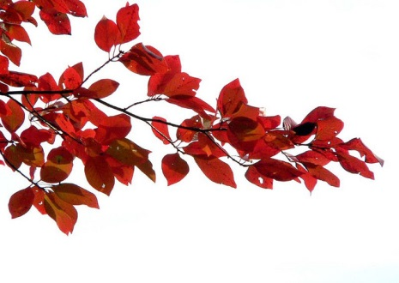

Programme
This year’s exciting-looking programme has been circulated to all members, as usual, by email and in addition Derek White, the new programme secretary, has produced an illustrated explanatory booklet which will be available at weekly meetings.
Annual Competition
An excellent display of work for this year’s competition “Urban Landscape” was won by Wright Platt.
Exhibitions Officer
There were no names put forward for the post of Exhibition Secretary at the last AGM. If anyone is interested in arranging, taking part in displaying and selling members’ work perhaps they would contact the Secretary or a member of the Committee. Peggy is willing to continue organising the Annual Exhibition at Bury Art Museum (3rd December 2016 to 4th February 2017) and is also arranging an exhibition and sale of members’ work at Bury Unitarian Church on Saturday 8th October from 10am to 4pm.
Website
Judith Jones, Gill Holt and Anne Saxon have been extremely busy in recent months designing a new website which it is hoped will be up and running at the start of the new term. Many thanks to them – it is beginning to look very impressive. Further details will be available soon.
Art Books
Pam Stone has recently up-dated and catalogued the art books which are now available for members to borrow.
Coach trips
Coach trips have been cancelled for the time being as it has become increasingly difficult to ensure a sufficient number of names to book and pay for necessary coaches. It may be possible to resume if enough interest and commitment is shown.
Autumn and Spring Visits
At the moment no visits have been arranged for the coming year
Membership
A reminder that the annual subscription of £35 is now due and can be paid at meetings or by post to our Treasurer, Phil Jones.
New Awards
In recognition of the dedication and support that David Swithenbank, President, and Mary Edyvean, Vice President have given Bury Art Society over many years, the Committee are instigating two new awards in their names to be presented at the Annual Exhibition. These will be in addition to the Millennium and the Tommy Valentine awards.

Peggy Hargreaves
Secretary

